You Are Invited!

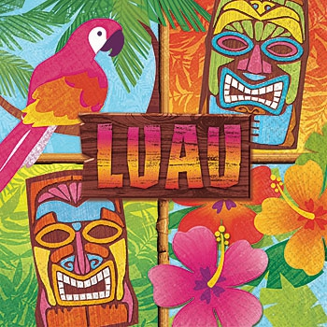
WHEN: Saturday, January 27, 2018 at 11:30 a.m.
WHERE: Knox United Church, 345 Pym Street, Parksville
We, the Knox congregation, guided by the Spirit, have boarded a ship and set sail on an amazing voyage of life. Without warning, we are caught in a violent storm at sea. Our ship goes aground, leaving us stranded on an unfamiliar island. We need to start a faith community on this island based upon shared core values.
Each of us is encouraged to reflect upon and to bring values we hold dear along on this journey. Our work is to discern from our individual values what will be the most important, shared core values for all of the Knox people!
What will this permit us to do? These core values will help to guide us over the next 4 to 5 years. They are our compass for the present and the future.
Join in the fun of a special gathering that includes a potluck luau lunch!
Dress in your favourite flowered shirt or muumuu. Bring your beach hat, flip flops and shades AND don’t forget to pack your essential values for our faith community.
To guarantee your reservation for this sailing, complete the following form and deposit it in the suitcase marked BON VOYAGE in the Narthex or email ???? on or before January 14, 2018.

RESERVATION FOR THE SS BON VOYAGE
Boarding Date: Saturday, January 27, 2018
Boarding Time: 11:30 a.m.
Guests for this sailing: Name(s) ______________________________________
________________________________________________________________________________
Please leave this form in the suitcase marked ‘BON VOYAGE’ in the Narthex. Thank You!

